# If else Switch case Ternary Assignment

1. **Using ternary operator compare 3 numbers and display the smallest number**
2. **A computer screen with text on it

   Description automatically generated**
3. **WAP to read a designation code and display his designation as a string. Use the following mapping.**
4. **– Software Developer**
5. **– Senior Software Developer**
6. **– Team Lead**
7. **– Senior Team Lead**

**anyother value – incorrect designation code**

**A :** 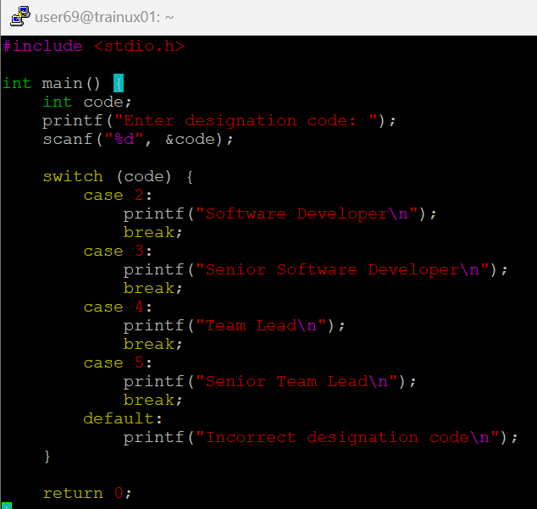

1. **WAP to test the eligibility for deployment post training. Need to fulfill all the 4 conditions. Read the score inputs from user at runtime. (Use if else and switch together).** 
   * 1. **Test1 Score >= 75%**
     2. **Test2 Score >= 75%**
     3. **Test3 Score >= 70%**
     4. **Project Score >=75%**
2. **A computer screen shot of a program

   Description automatically generated**

